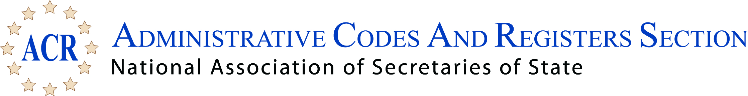

2017 Summer Conference
Westin Indianapolis - Indianapolis, Indiana
July 7 - 10, 2017

ACR Second Business Meeting Agenda
Sunday, July 9, 2017, 3:00 p.m.

- Call to Order - Emily Caudill, President
- Winter Meeting
- February 16-19, 2018, Fairmont Georgetown, Washington, DC
- Summer Conference
- July 13-16, 2018, Loews Philadelphia, Philadelphia, PA
- Proposed Bylaws Changes
- Certificates of Appreciation
- Other Business and Open Discussion
- Program Evaluation Survey
- Adjourn

