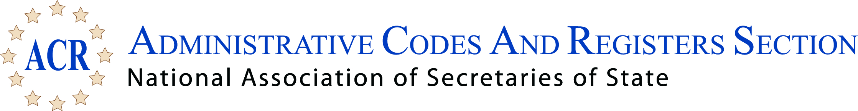

2017 Summer Conference
Westin Indianapolis - Indianapolis, Indiana
July 7 - 10, 2017

ACR First Business Meeting Agenda
Saturday, July 8, 2017, 1:30 p.m.

- Call to Order - Emily Caudill, President
- Welcome - Introduction of Officers
- Treasurer's Report, Deanna Maiolo, Secretary-Treasurer
- State and Federal Survey, Chris Coffman, Vice President
- Proposed Bylaws Changes
- Website & Archives Committees Reports
- Other Business and Open Discussion
- Adjourn

ACR Executive Committee 2016-2018
President: Emily Caudill, KY
Vice President: Chris Coffman, OK
Secretary-Treasurer Deanne Maiolo, CO

Pacific West: Julie Yamaka, WA
Midwest: Bruce Hoesly, WI
Mountain West: Vacant (AZ, CO, ID, MT, NM, UT, WY)
Mid-Atlantic: Yvette Smallwood, DE
Northern Plains: Stephanie Hoff, IA
Northeast: Scott Eaton, NH
South: Robert Sumners, TX
South Atlantic: Molly Masich, NC

