HOW TO USE E-RULEMAKING SYSTEM
FLORIDA ADMINISTRATIVE WEEKLY

WEB ADDRESS: https://www.flrules.org/agency/login.asp

YOU MUST HAVE AN ACCOUNT SET UP IN THE SYSTEM WITH A USER NAME, PASSWORD AND A “ROLE” ASSIGNMENT.

LOG IN WITH YOUR USER NAME AND PASS WORD UNDER “AGENCY LOGIN”.

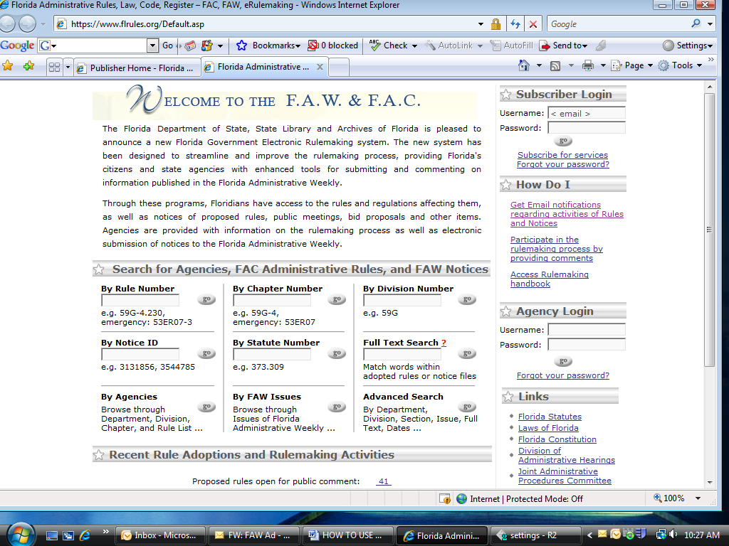

SELECT YOUR “ROLE ASSIGNMENT BY HIGHLIGHTING IT AND CLICK CONTINUE:

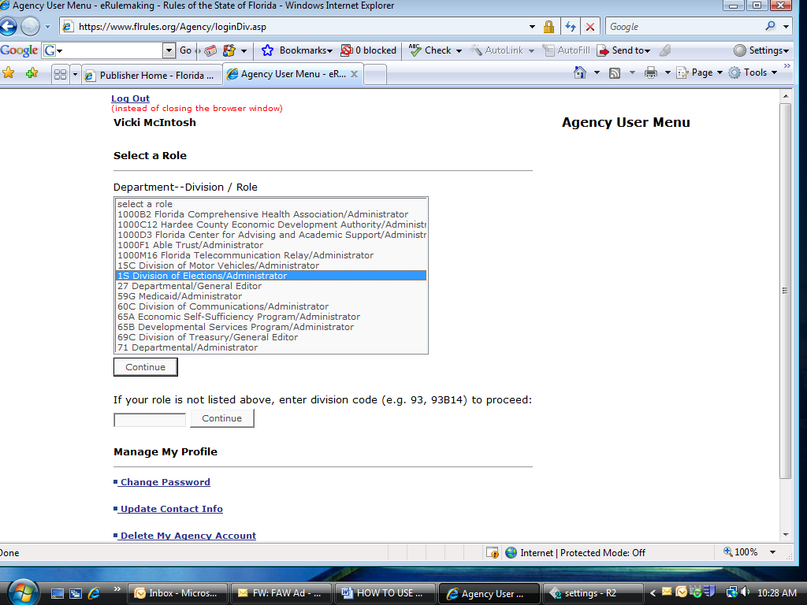

WITH THIS SYSTEM, YOU MUST HAVE A “ROLE ASSIGNMENT” IN ORDER TO ACCESS CERTAIN PARTS OF THE WEBSITE:

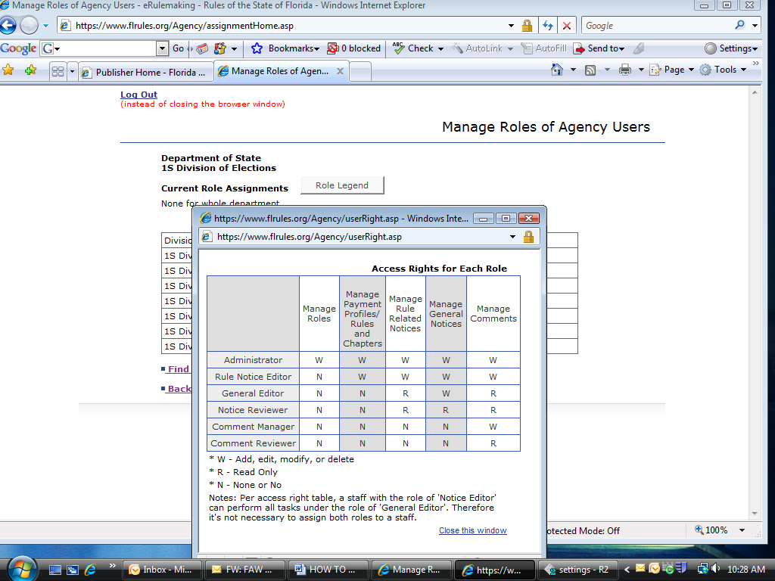

ON THE “MAIN MENU – AGENCY USER” PAGE, SELECT THE LINK FOR “MANAGE PAYMENT PROFILES OF THE ORGANIZATION” AND MAKE SURE THAT A PAYMENT PROFILE HAS BEEN ENTERED FOR YOUR NOTICE. IF NOT, A PROFILE MUST BE ADDED BEFORE YOU PROCEED TO THE NEXT STEP.

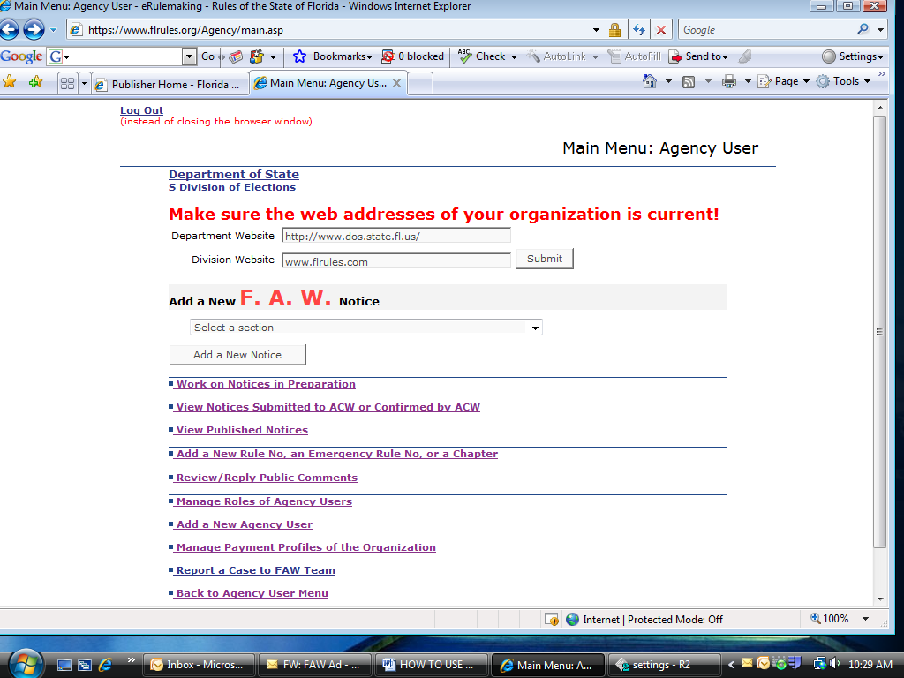

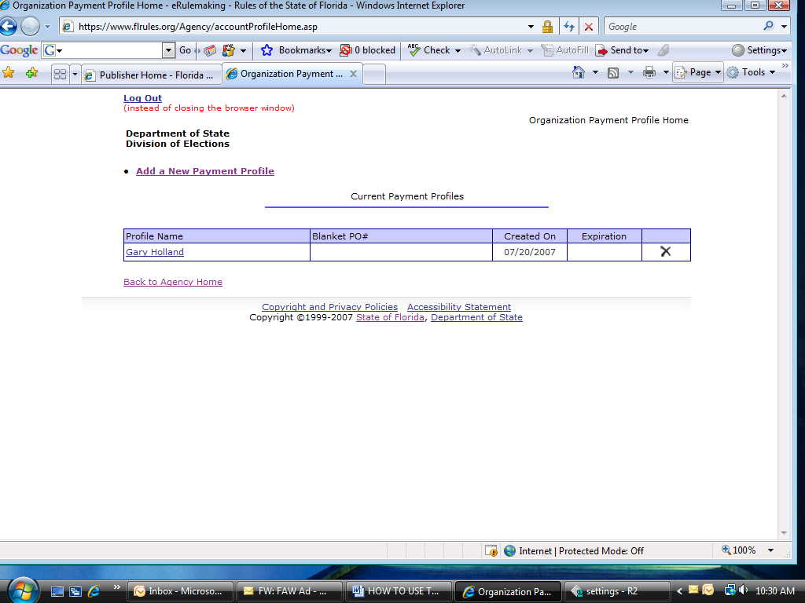

NEXT, ON THE MAIN AGENCY PAGE, USE THE DROP DOWN MENU TO SELECT THE TYPE OF NOTICE THAT YOU NEED TO CREATE, THEN CLICK ON “ADD A NEW NOTICE”

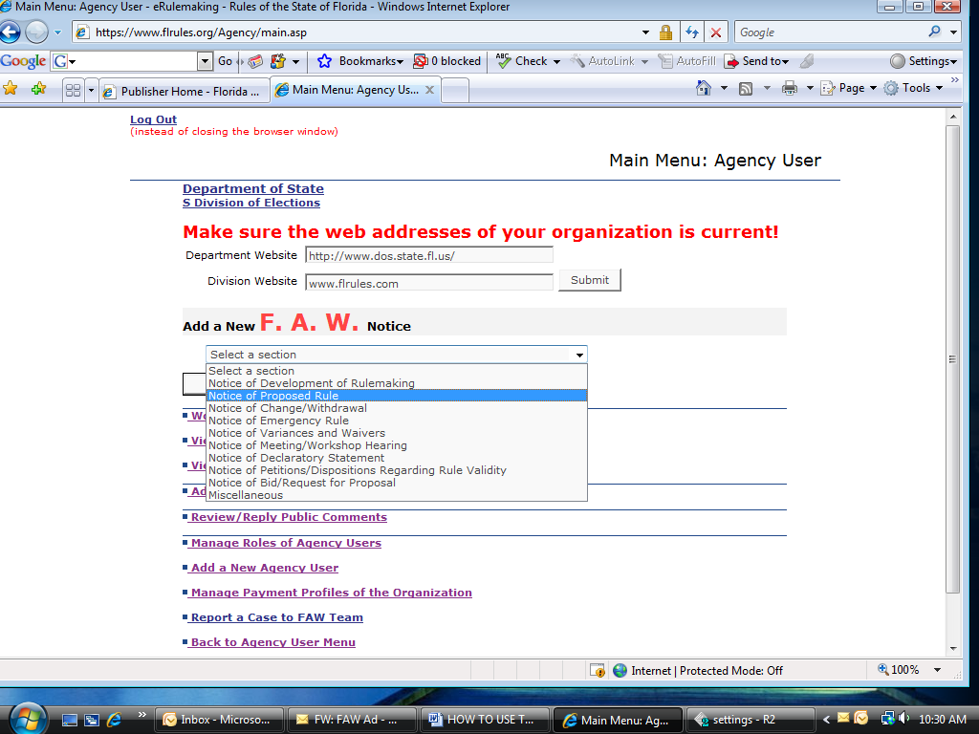

ON THE NEXT PAGE (FOR RULE RELATED NOTICES), USE THE DROP DOWN MENU TO SELECT THE CHAPTER NUMBER FOR YOUR NOTICE – CLICK CONTINUE.

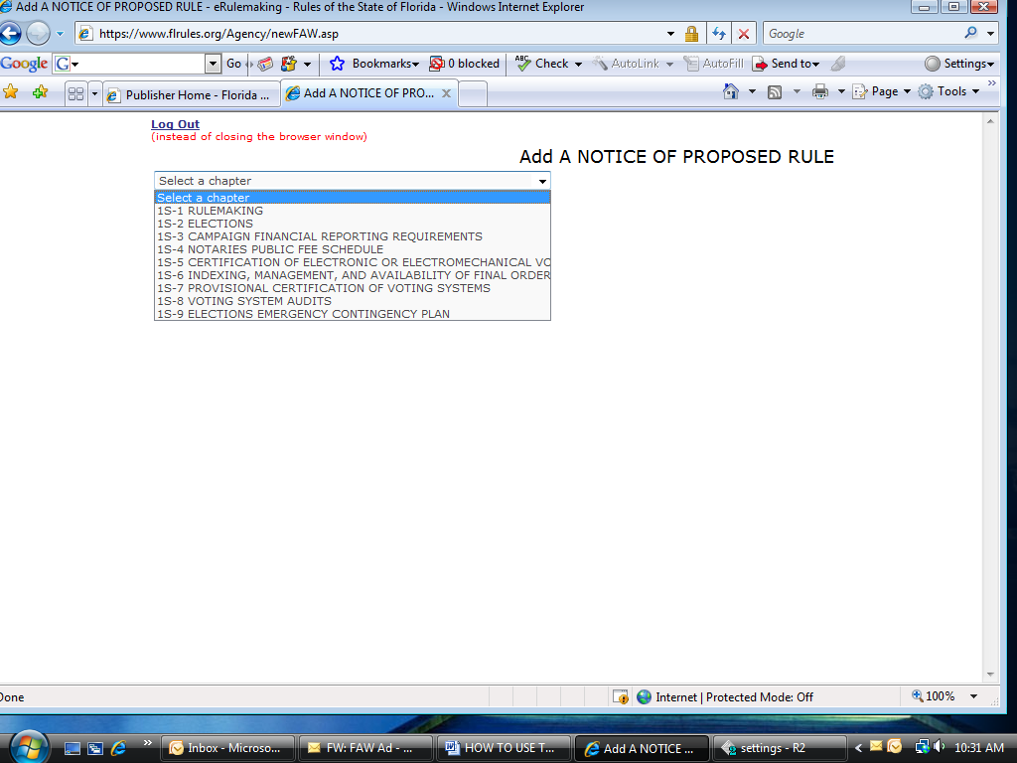

SELECT THE RULE NUMBER(S) TO BE INCLUDED AND THEN COMPLETE ALL NOTICE TEMPLATE FIELDS.

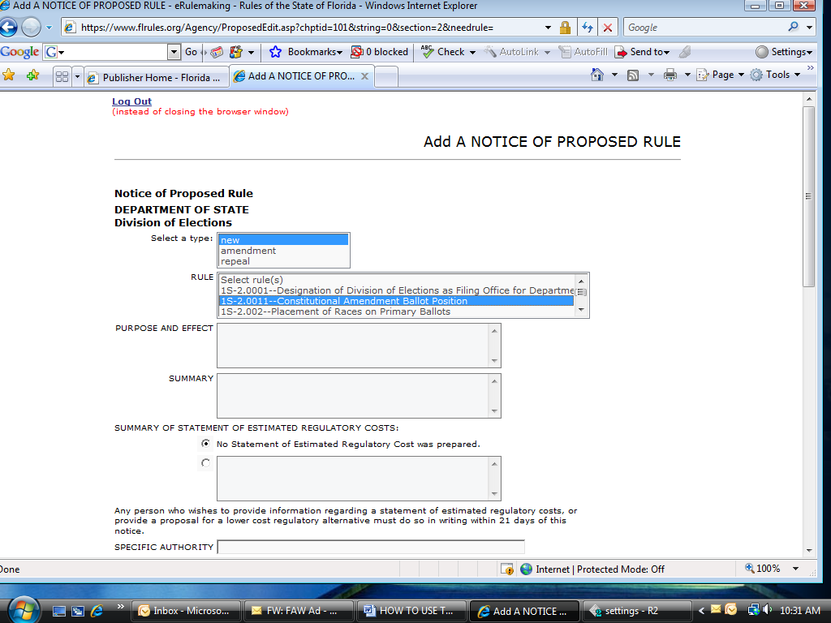

ONCE THE TEMPLATE IS COMPLETED, SAVE AND CONTINUE, COPY AND PASTE RULE TEXT INTO NOTICE TEMPLATE TEXT BOX. CONTINUE, THEN “SAVE TO HTML FILE AND FINISH.

YOU WILL THEN BE ON THE “NOTICE HOME” PAGE, WHICH IS THE “SUBMITTAL” PAGE.
- SELECT THE ISSUE IN WHICH THE NOTICE IS TO BE PUBLISHED
- SELECT THE APPROPRIATE PAYMENT PROFILE
- SELECT THE NAME OF THE PERSON TO RECEIVE THE CONFIRMATION EMAIL AND THE PERSON (FOR PROPOSED RULES) WHO IS TO RECEIVE COMMENT EMAIL.
- CLICK “SUBMIT”

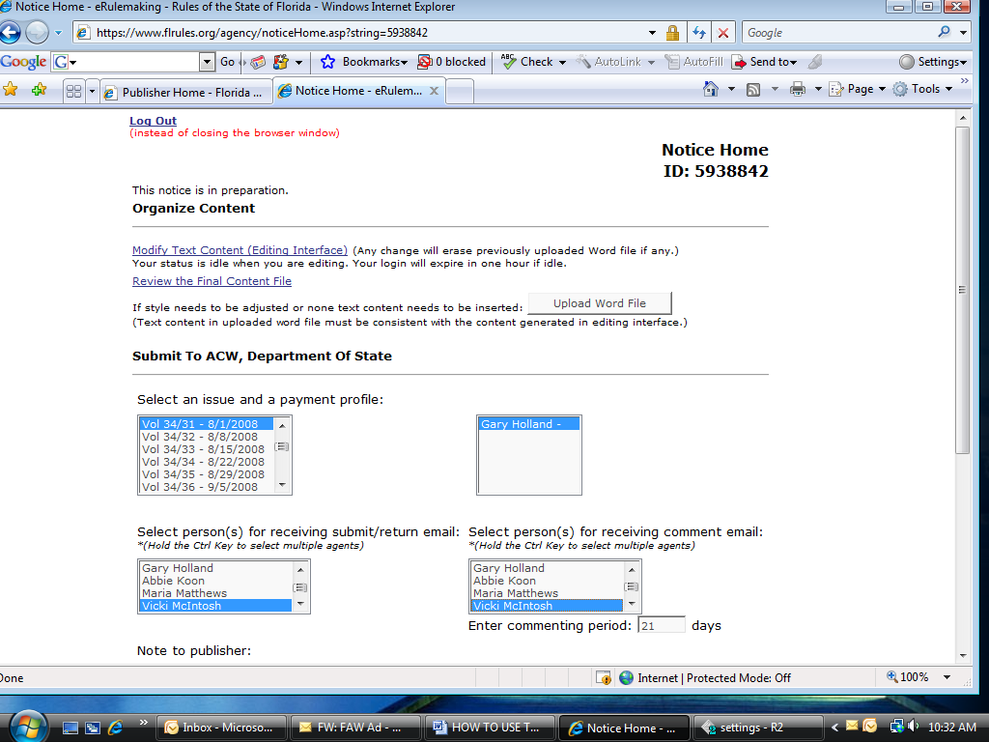

OTHER LINKS ON THE AGENCY HOME PAGE:

WORK ON NOTICES IN PREPARATION: Allows you to start a notice, save it into the system, and come back later to make modifications before submitting the notice.

VIEW NOTICES SUBMITTED TO ACW OR CONFIRMED BY ACW: Gives you a list of notices (with Notice ID numbers) that you have submitted and a list of notices that have been “Confirmed” for publication.

VIEW PUBLISHED NOTICES: Gives you a list of notices that have be “published” on the website.

There are other links for adding new chapter and rule number, managing public comments and links for Managing Roles of Agency Users and Adding New Agency Users and Payment Profiles.

